### **Programming Assignment**

Using the Book, BookCopy, Borrower, Librarian and BookLended tables created for your library database in Unit 5, populate them with data using the following information. If your tables have additional attributes that are not included in the following list, then add appropriate values to populate your tables. You must submit all of the SQL statements required to create the tables and any indexes you deem appropriate (NOTE: indexes are NOT required but you may include them where you feel they would be appropriate), implement appropriate constraints including referential integrity and uniqueness and populate the tables with data (insert statements). Your assignment MUST contain ALL of the SQL statements to create the tables, populate the tables and define all of the appropriate constraints. Further you must issue a select statement and include both the select statement and the output of the select statement (using a screen shot of your database’s output) that shows the contents of each table after you have completed populating the tables with data (after you have executed all of the insert statements).

**Assignment Instructions:**

* the assignment must include the SQL DDL and DML statements required to implement at least the following relations (both to create and populate):
  + Book
  + Borrower
  + BookLended
  + Librarian
* the assignment must make appropriate use of Not Null parameters to ensure data validity. The minimum standard will be measured against the instructor’s example and will be based upon rules associated with primary and foreign keys and integrity constraint rules.
* the assignment must include a select statement that selects the contents of each table and include the output of this select statement when executed against the populated database.
* the assignment must make appropriate use of constraint clauses to ensure the referential integrity of the relations in the schema. The minimum standard will be measured against the instructor’s example and will be based upon rules associated with primary and foreign keys and integrity constraint rules.
* the assignment must make appropriate use of keys including the automatic generation of key values where appropriate.

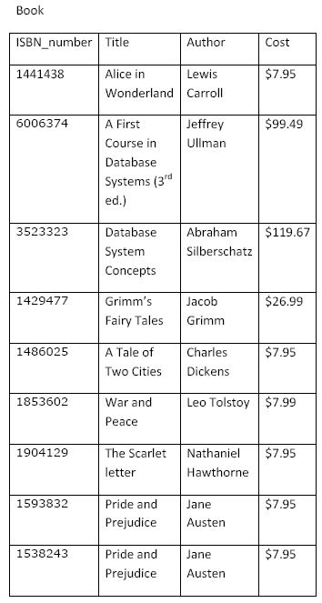

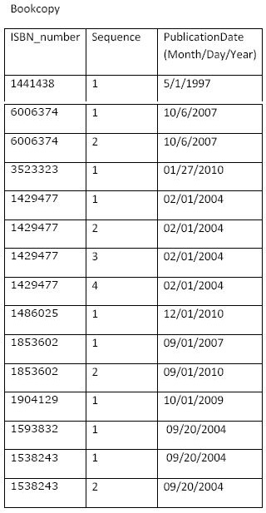

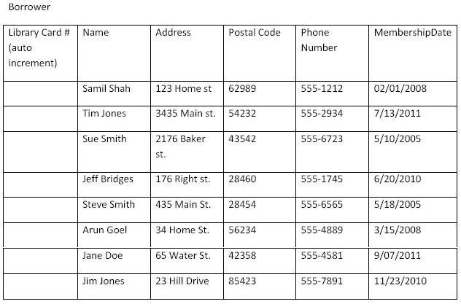

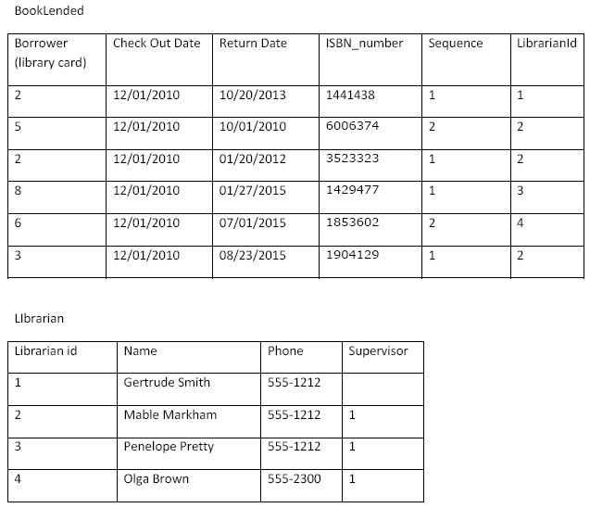

**My Solution:**

create table librarian (

librarianid integer not null,

name char(40) not null,

phonenumber char(20),

supervisor integer

);

alter table librarian add unique (librarianid);

alter table librarian add primary key (librarianid);

create table borrower (

librarycard integer GENERATED BY DEFAULT AS IDENTITY, name char(40) not null,

address char(40), postalcode char(20), phonenumber char(20), membershipdate date

);

create table book (

title varchar(60) not null, author varchar(40),

cost decimal(10,2), isbn_number integer not null

);

alter table book add unique (isbn_number);

alter table book add primary key (isbn_number);

create table bookcopy (

isbn_number integer not null, sequence integer not null, publicationdate date

);

alter table bookcopy add primary key (isbn_number, sequence);

alter table bookcopy add CONSTRAINT bookcopy_uniq UNIQUE (ISBN_number, sequence);

alter table bookcopy add CONSTRAINT book_fkey FOREIGN KEY (isbn_number) REFERENCES book (isbn_number) ON DELETE CASCADE;

create table booklended (

librarycard integer not null,

checkoutdate date not null,

returndate date,

ISBN_number integer not null, sequence integer not null, librarianid integer not null

);

alter table booklended add PRIMARY KEY (ISBN_number, sequence, librarycard, checkoutdate);

alter table booklended add CONSTRAINT booklended_uniq UNIQUE (ISBN_number, sequence, librarycard, checkoutdate);

alter table booklended add CONSTRAINT borrower_fkey FOREIGN KEY (librarycard) REFERENCES borrower (librarycard) ON DELETE CASCADE;

alter table booklended add CONSTRAINT librarian_fkey FOREIGN KEY (librarianid) REFERENCES librarian (librarianid) ON DELETE CASCADE;

alter table booklended add CONSTRAINT bookcopy_fkey FOREIGN KEY (isbn_number, sequence) REFERENCES bookcopy (isbn_number, sequence);

INSERT INTO BOOK VALUES ('Alice in Wonderland', 'Lewis Carroll', 7.95, 1441438);

INSERT INTO BOOK VALUES ('A First Course in Database Systems',

'Jeffrey Ullman', 99.49, 6006374);

INSERT INTO BOOK VALUES ('Database System Concepts', 'Abraham

Silberschatz', 119.67, 3523323);

INSERT INTO BOOK VALUES ("Grimm's Fairy Tales", 'Jacob Grimm', 7.95, 1429477);

INSERT INTO BOOK VALUES ('A Tale of Two Cities', 'Charles Dickens',

7.95, 1486025);

INSERT INTO BOOK VALUES ('War and Peace', 'Leo Tolstoy', 7.99, 1853602);

INSERT INTO BOOK VALUES ('The Scarlet Letter', 'Nathaniel Hawthorne',

7.95, 1904129);

INSERT INTO BOOK VALUES ('Pride and Prejudice', 'Jane AUsten', 7.95, 1593832);

INSERT INTO BOOK VALUES ('Pride and Prejudice', 'Jane AUsten', 7.95, 1538243);

---

INSERT INTO BOOKCOPY VALUES (1441438, 1, '1-5-1997');

INSERT INTO BOOKCOPY VALUES (6006374, 1, '6-10-2007');

INSERT INTO BOOKCOPY VALUES (6006374, 2, '6-10-2007');

INSERT INTO BOOKCOPY VALUES (3523323, 1, '27-1-2010');

INSERT INTO BOOKCOPY VALUES (1429477, 1, '1-2-2004');

INSERT INTO BOOKCOPY VALUES (1429477, 2, '1-2-2004');

INSERT INTO BOOKCOPY VALUES (1429477, 3, '1-2-2004');

INSERT INTO BOOKCOPY VALUES (1429477, 4, '1-2-2004');

INSERT INTO BOOKCOPY VALUES (1486025, 1, '1-12-2010');

INSERT INTO BOOKCOPY VALUES (1853602, 1, '1-9-2007');

INSERT INTO BOOKCOPY VALUES (1853602, 2, '1-9-2010');

INSERT INTO BOOKCOPY VALUES (1904129, 1, '1-10-2009');

INSERT INTO BOOKCOPY VALUES (1593832, 1, '20-9-2004');

INSERT INTO BOOKCOPY VALUES (1538243, 1, '20-9-2004');

INSERT INTO BOOKCOPY VALUES (1538243, 2, '20-9-2004');

---

INSERT INTO BORROWER (NAME, ADDRESS, POSTALCODE, PHONENUMBER, MEMBERSHIPDATE)

VALUES ('Samil Shah', '123 Home St', 62989, '555-1212', '1-2-2008');

INSERT INTO BORROWER (NAME, ADDRESS, POSTALCODE, PHONENUMBER, MEMBERSHIPDATE)

VALUES ('Tim Jones', '3435 Main St', 54232, '555-2934', '13-7-2011');

INSERT INTO BORROWER (NAME, ADDRESS, POSTALCODE, PHONENUMBER, MEMBERSHIPDATE)

VALUES ('Sue Smith', '2176 Baker St.', 43542, '555-6723', '10-5-2005');

INSERT INTO BORROWER (NAME, ADDRESS, POSTALCODE, PHONENUMBER, MEMBERSHIPDATE)

VALUES ('Jeff Bridges', '176 Right st', 28460, '555-1745', '20-6-2010');

INSERT INTO BORROWER (NAME, ADDRESS, POSTALCODE, PHONENUMBER, MEMBERSHIPDATE)

VALUES ('Steve Smith', '435 Main st', 28454, '555-6565', '18-5-2005');

INSERT INTO BORROWER (NAME, ADDRESS, POSTALCODE, PHONENUMBER, MEMBERSHIPDATE)

VALUES ('Arun Goel', '34 Home St', 56234, '555-4889', '15-3-2008');

INSERT INTO BORROWER (NAME, ADDRESS, POSTALCODE, PHONENUMBER, MEMBERSHIPDATE)

VALUES ('Jane Doe', '65 Water St', 42358, '555-4581', '7-9-2011');

INSERT INTO BORROWER (NAME, ADDRESS, POSTALCODE, PHONENUMBER, MEMBERSHIPDATE)

VALUES ('Jim Jones', '23 Hill Drive', 85423, '555-7891', '23-11-2010');

--

INSERT INTO LIBRARIAN VALUES (1, 'Gertrude Smith', '555-1212',

null);

INSERT INTO LIBRARIAN VALUES (2, 'Mable Markham', '555-1212',

1);

INSERT INTO LIBRARIAN VALUES (3, 'Penelope Pretty', '555-1212',

1);

INSERT INTO LIBRARIAN VALUES (4, 'Olga Brown', '555-2300',

1);

---

INSERT INTO BOOKLENDED VALUES (2,'1-12-2010', '20-10-2013', 1441438, 1, 1);

INSERT INTO BOOKLENDED VALUES (5,'1-12-2010', '1-10-2010', 6006374, 2, 2);

INSERT INTO BOOKLENDED VALUES (2,'1-12-2010', '20-1-2012', 3523323, 1, 2);

INSERT INTO BOOKLENDED VALUES (8,'1-12-2010', '27-1-2015', 1429477, 1, 3);

INSERT INTO BOOKLENDED VALUES (6,'1-12-2010', '1-7-2015', 1853602, 2, 4);

INSERT INTO BOOKLENDED VALUES (3,'1-12-2010', '23-8-2015', 1904129, 1, 2);

***Select Statements:***

SELECT LIBRARIANID, NAME, PHONENUMBER, SUPERVISOR FROM LIBRARIAN;